**Part 2 – Form**

To test the usability of the new site, our client would like to see the Book A Trip form.

The form must use the **GET method**, and have the following input fields:

* Email (as *text* – no validation needed)
* Location (as *select* with 2 options)
* Trip Date (as *date*)

See example below:

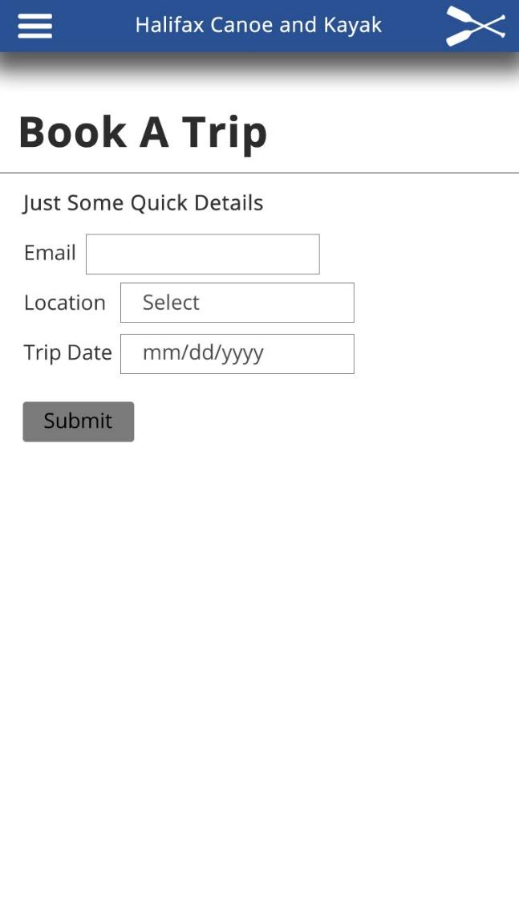 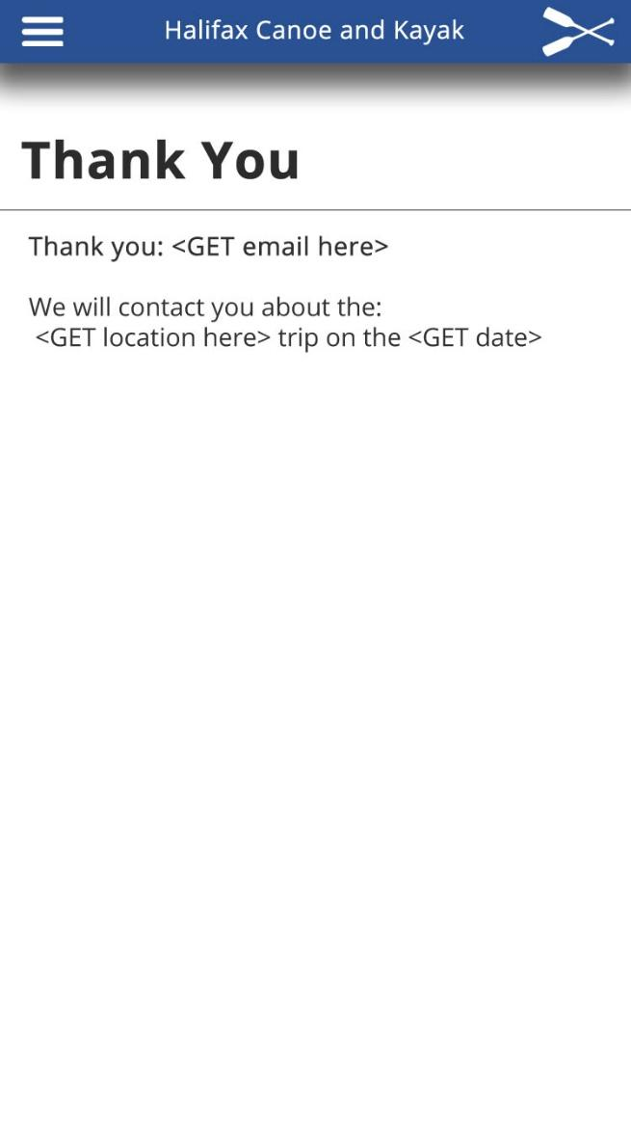

**Pro Tip: Use Part 1 style as a template.**

Create book.php and thank-you.php

* book.php will have the form
* thank-you.php will GET the data entered in the form and display it back in a sentence or two

(similar to the example above)

**Supplied Assets:**

* The main image:

<https://raw.githubusercontent.com/Zulinov/skillsProjects/main/canoe.jpg>

* Hamburger icon: <https://raw.githubusercontent.com/Zulinov/skillsProjects/main/hamburger.png>

**Submitting Instructions:**

1. Upload your complete project (html file, css file(s), images, etc.) to GitHub.

(You’ll be uploading a bunch, so stay organized)

1. Then post the URL to your project here: <https://docs.google.com/spreadsheets/d/1nlXiprAQLNlj2BGUeVXYcxjB1lgx6NGA9cxVU6YRPGU/edit?usp=sharing>